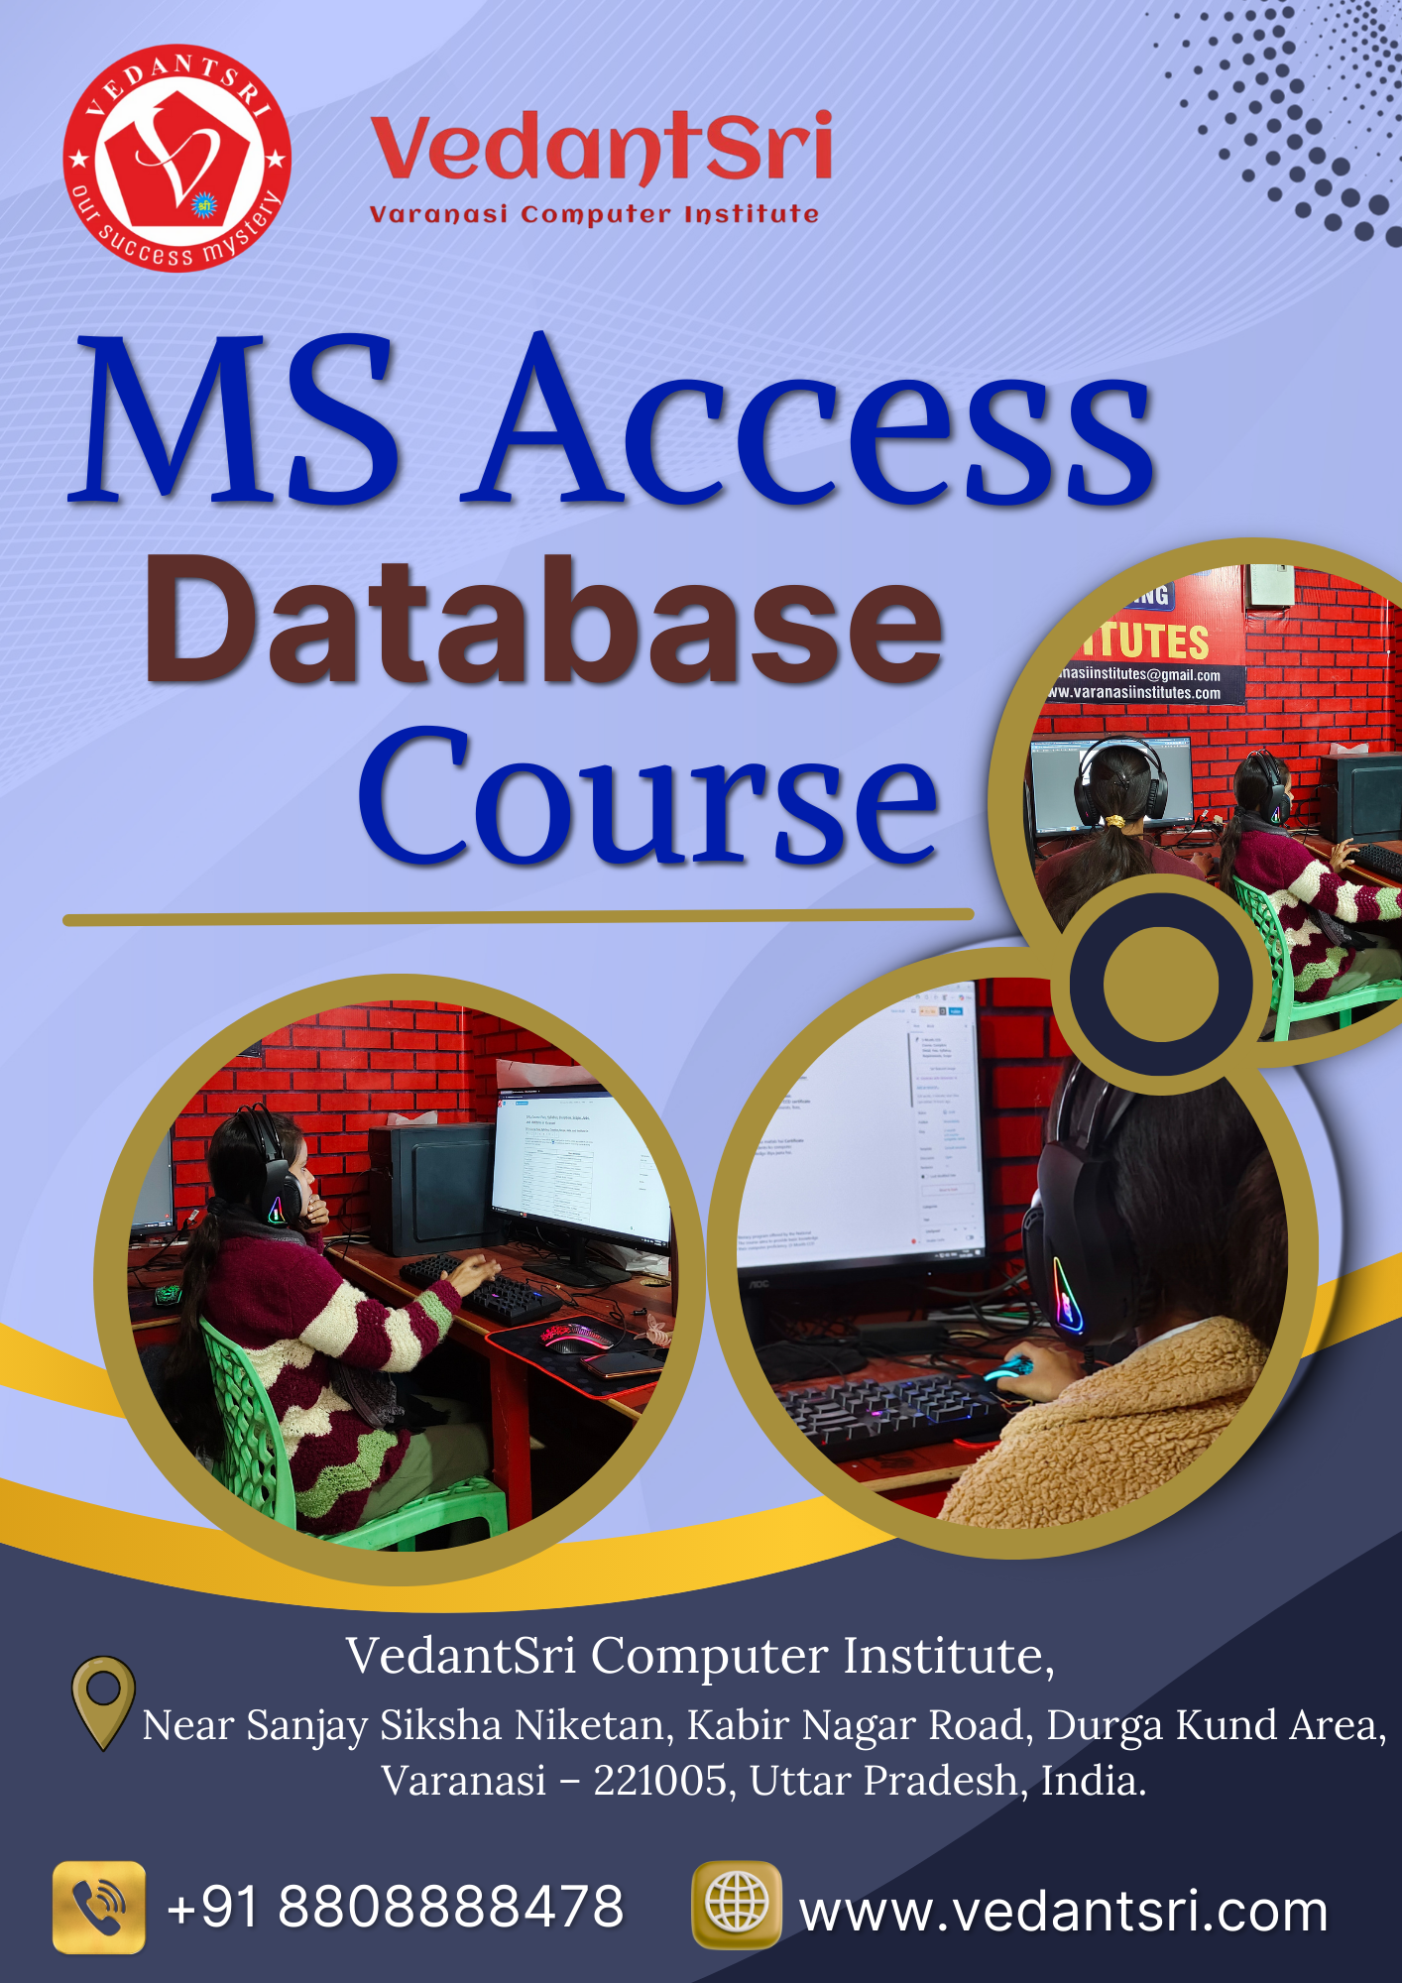
Contents
Best MS Access Database Course Fees, Duration, Scope, Syllabus, top 10 Jobs and Institutes in Varanasi 5
Best MS Access Database Course 6
Is post me hum detail me jaanenge: 7
MS Access Database Course kya hai 7
What is MS Access Database Course? 8
MS Access Database Course Me students ko ye sab sikhaye jate hai: 9
Why Learn MS Access in Varanasi? 11
Example ke taur par: 11
MS Access Course Fees in Varanasi 13
Approximate Fees Structure: 13
MS Access Course Duration 15
MS Access Course Syllabus 16
Module 1: Database Basics 17
Module 2: Tables 17
Module 3: Data Handling 18
Module 4: Queries 18
Module 5: Forms 19
Module 6: Reports 20
Module 7: Relationships 20
Module 8: Advanced (Optional) 21
Scope of MS Access Course 22
Eligibility for MS Access Course 24
Is course ke liye: 24
Admission Process at VedantSri Computer Institute 25
Step 1 25
Step 2 25
Step 3 25
Step 4 26
Best Institutes for MS Access Course in Varanasi 26
Top 10 Jobs After MS Access Database Course 27
1. Data Entry Operator 28
2. Office Assistant 29
3. MIS Executive (Management Information Systems) 29
4. Database Assistant 30
5. Data Analyst (Entry Level) 31
6. Computer Operator 31
7. Sales/Inventory Coordinator 32
8. Records / File Clerk 32
9. Administrative Assistant 33
10. Freelancer / MS Access Consultant 33
Why Choose VedantSri Computer Institute? 34
VedantSri Institute ka mission hai: 35
Conclusion 35
Is course ke through aap: 37
CONTACT & REGISTRATION 38
Contact Details 38

Best MS Access Database Course Fees, Duration, Scope, Syllabus, top 10 Jobs and Institutes in Varanasi
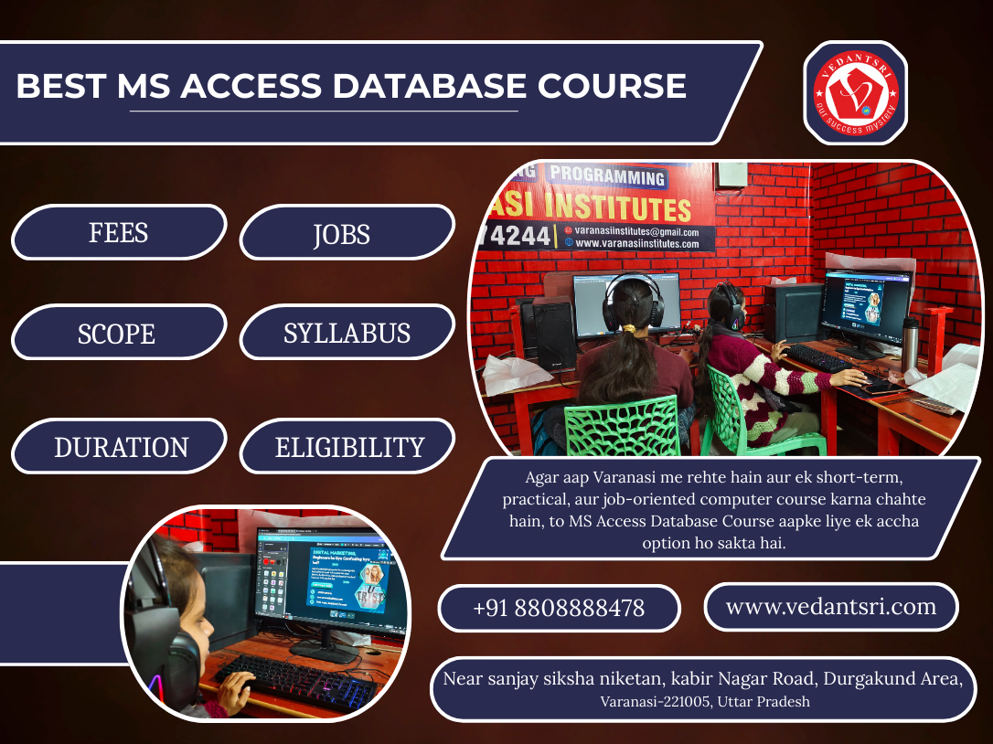
Aaj ke digital era me data sabse valuable resource ban chuka hai. Chahe school ho, college ho, hospital ho, private company ho, ya chhota business ho, har jagah data ka systematic management bahut zaroori ho gaya hai. Data ko safely store karna, time par retrieve karna, aur reports ke roop me present karna kisi bhi organization ke liye important task hota hai. Isi need ko fulfill karne ke liye database software ka use kiya jata hai.

Best MS Access Database Course
Microsoft ka popular database software MS Access ek aisa tool hai jo small aur medium-level organizations me widely use hota hai. Ye software user-friendly hai aur beginners ke liye bhi easy hota hai.
Agar aap Varanasi me rehte hain aur ek short-term, practical, aur job-oriented computer course karna chahte hain, to MS Access Database Course aapke liye ek accha option ho sakta hai.
VedantSri Computer Institute, Varanasi ke according, MS Access course students ko sirf software chalana nahi sikhate balki unhe database ko professionally manage karna bhi sikhate hain, jo aaj ke competitive job market me bahut useful skill hai.

Is post me hum detail me jaanenge:

MS Access Database Course kya hai
1. Course fees
2. Course duration
3. Scope and career opportunities
4. Complete syllabus
5. Admission process
6. Institutes in Varanasi
7. jobs and salary prospects

What is MS Access Database Course?
MS Access (Microsoft Access) ek Relational Database Management System (RDBMS) hai jo Microsoft Office package ka part hota hai. Iska use data ko store, organize, update, aur analyze karne ke liye hota hai. MS Access ka interface simple hota hai aur ye Windows operating system par smoothly kaam karta hai.

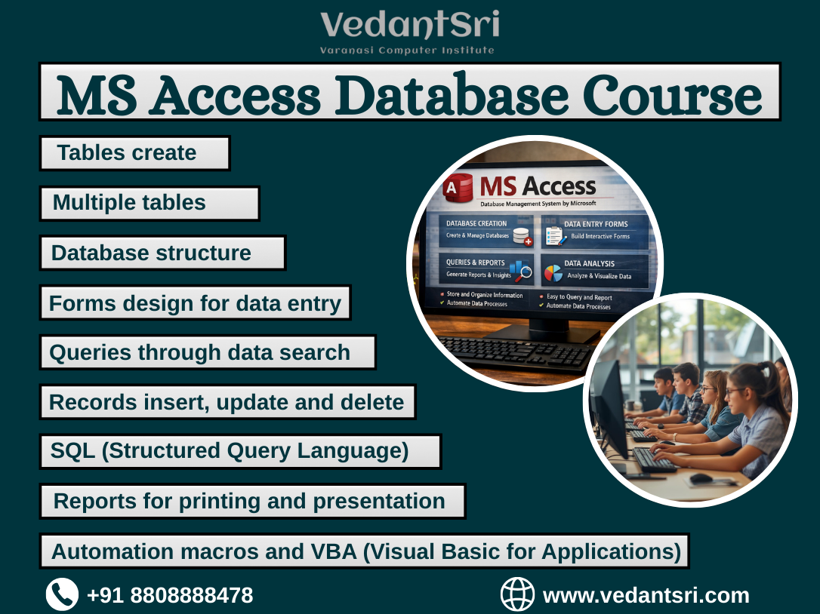
MS Access Database Course Me students ko ye sab sikhaye jate hai:
MS Access Database Course Fees
- Database ka structure samajhna
- Tables create karna
- Records insert, update aur delete karna
- Queries ke through data search aur filter karna
- Forms design karna for data entry
- Reports banana for printing and presentation
- Multiple tables ke beech relationship banana
- SQL (Structured Query Language) ka basic concept
- Automation ke liye macros aur VBA (Visual Basic for Applications) advanced level
VedantSri Computer Institute mein MS Access course is tarah design kiya gaya hai ki:
- Beginners asaani se seekh saken
- Har topic practical examples ke saath samjhaya jaye
- Students ko job-ready banaya ja sake

Why Learn MS Access in Varanasi?
Varanasi ek educational aur commercial city hai jahan par:
- Schools aur colleges
- Hospitals aur clinics
- Coaching institutes
- NGOs
- Shops and small businesses
- Private offices
Sab jagah data ka kaam hota hai.

Example ke taur par:
- Schools me student records
- Hospitals me patient database
- Offices me employee details
- Shops me customer aur billing data
- NGOs me donor aur beneficiary records
- Ye sab data MS Access ke through properly manage kiya ja sakta hai.
VedantSri Institute ke experience ke according, MS Access seekhne ke fayde ye hain:
- Office jobs ke liye useful skill
- Jobs see data entry jobs and better profiles.
- MIS aur admin jobs ke liye helpful
- Tally aur Excel ke saath powerful combination
- Fresher students ke liye easy learning
- Housewives aur businessmen ke liye bhi practical use

MS Access Course Fees in Varanasi
Varanasi mein MS Access course ki fees institute aur course level par depend karti hai.

Approximate Fees Structure:
Course Type | Fees Range
Basic MS Access Course | ₹2,000 – ₹4,000
Intermediate Course | ₹4,000 – ₹7,000
Advanced Course with Project | ₹7,000 – ₹12,000
VedantSri Computer Institute, Varanasi mein:
- Fees reasonable rakhi jati hai
- Installment facility available hoti hai
- Combo courses (MS Office + MS Access) bhi available hote hain
- Free demo class ka option hota hai
- Students ke liye special discount schemes bhi di jati

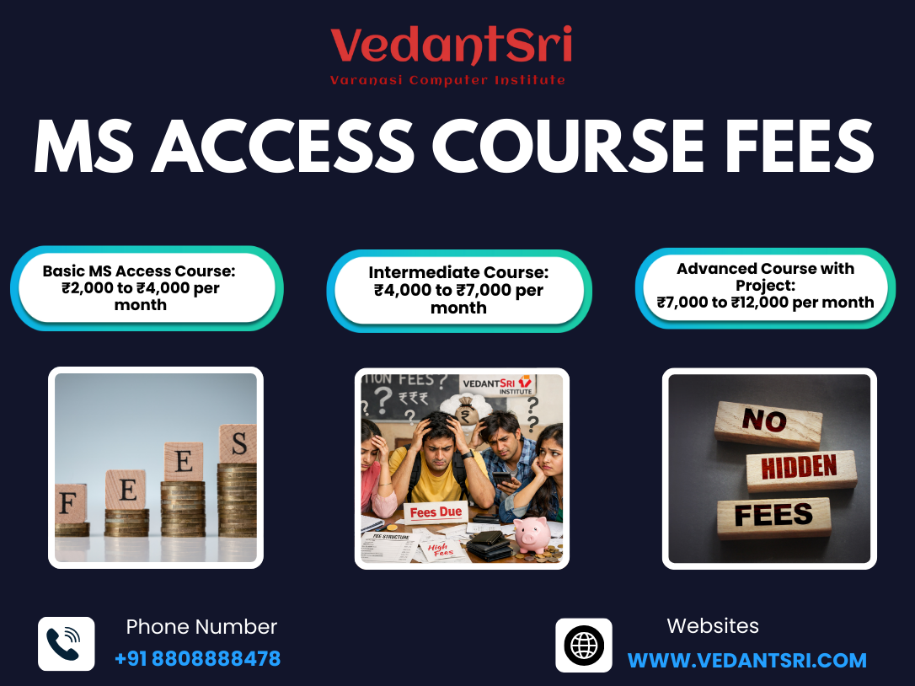
MS Access Course Duration
MS Access course ki duration syllabus aur level par depend karti hai.
VedantSri Institute me students ke liye:

Course Level | Duration
Basic Level | 15–20 Days
Regular Course | 1 Month
Advanced Level | 2–3 Months
- Weekend batch
- Working students ke liye flexible timing
- Regular batch

MS Access Course Syllabus
VedantSri Computer Institute ka syllabus industry-oriented aur job-focused hota hai, jismein theory ke saath-saath practical training bhi di jati hai.

Module 1: Database Basics
- What is Data
- What is a database?
- Difference between DBMS and RDBMS
- Types of Databases
- Introduction to MS Access
- MS Access interface and tools

Module 2: Tables
- Creating tables
- Field names and data types
- Primary key
- Field properties
- Data validation rules
- Table design view

Module 3: Data Handling
- Insert records
- Update and delete records
- Sorting and filtering
- Import and export data
- Linking external data sources

Module 4: Queries
- Select query
- Parameter query
- Action query
- Aggregate functions
- SQL basics
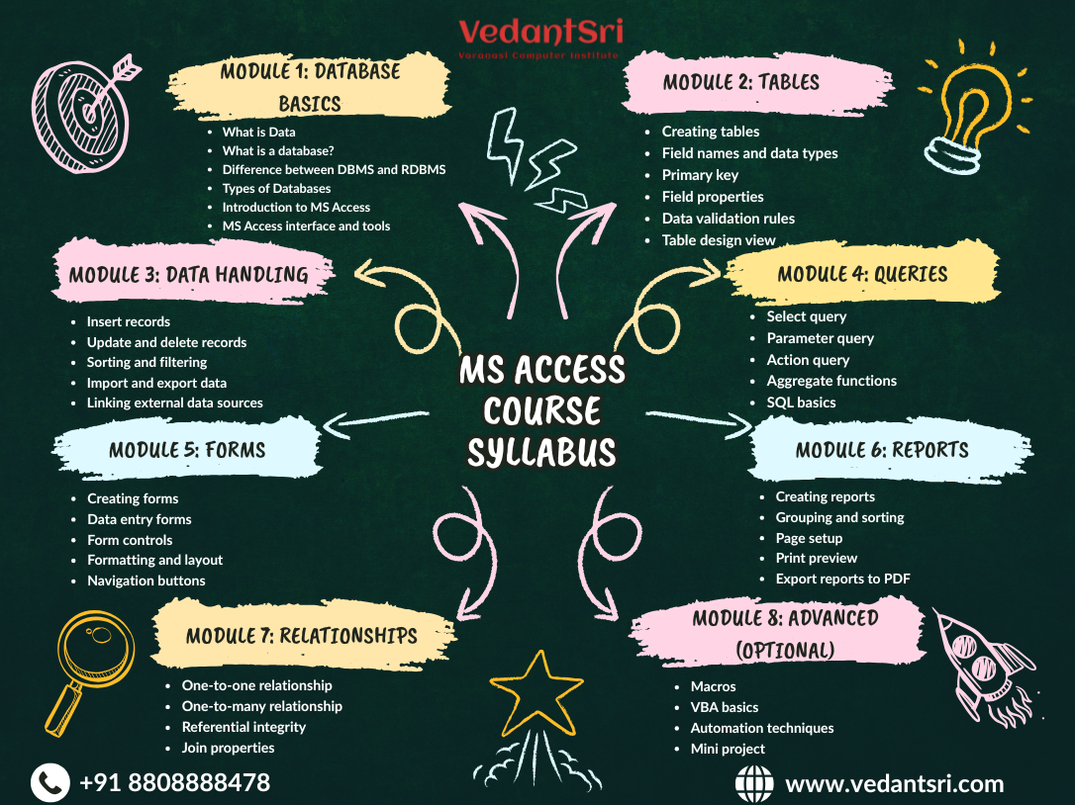
- Multiple table queries
MS Access Course Syllabus

Module 5: Forms
- Creating forms
- Data entry forms
- Form controls
- Formatting and layout
- Navigation buttons

Module 6: Reports
- Creating reports
- Grouping and sorting
- Page setup
- Print preview
- Export reports to PDF

Module 7: Relationships
- One-to-one relationship
- One-to-many relationship
- Referential integrity
- Join properties

Module 8: Advanced (Optional)
- Macros
- VBA basics
- Automation techniques
- Mini project
VedantSri Institute me:
- Practical database project diya jata hai
- Real-life data examples par practice karai jati hai

- Course completion ke baad certificate diya jata hai

Scope of MS Access Course
MS Access ka scope aaj bhi kaafi strong hai, khaaskar in jagaho par:
- Office work
- Education sector
- Healthcare sector
- NGOs and social organizations
- Small businesses
- Retail shops
Future me students in roles me kaam kar sakte hain:
- Data Assistant
- Office Administrator
- Database Operator
- Computer Operator
- Data entry
VedantSri Institute ke according:
“MS Access ek foundation course hai jo future me SQL (Structured Query Language), Business Intelligence, Advanced Excel, Tally aur programming courses ke liye base banata hai.”

Eligibility for MS Access Course
- 10th pass students
- 12th pass students
- Graduation students
- Office staff
- Business owners
- Housewives
- Any person with basic computer knowledge

Is course ke liye:
- No age limit
- No technical background required

Admission Process at VedantSri Computer Institute
VedantSri Computer Institute, Varanasi me admission process simple aur student-friendly hota hai.

Step 1
Institute visit karke inquiry karein ya phone par details lein

Step 2
Apna suitable course select karein

Step 3
Documents submit karein:
- Aadhar Card
- 2 passport-size photos
- Qualification proof

Step 4
Fees payment karke batch join karein

Best Institutes for MS Access Course in Varanasi
Varanasi me kai computer training institutes hain, lekin VedantSri Computer Institute students ke beech popular hai kyunki:
- Experienced trainers
- Practical computer lab
- Affordable fee structure
- Course completion certificate
- job guidance and support
- Multiple computer courses under one roof
VedantSri Institute ka main focus hota hai:
- Quality education
- Practical knowledge
- Career-oriented training

Top 10 Jobs After MS Access Database Course
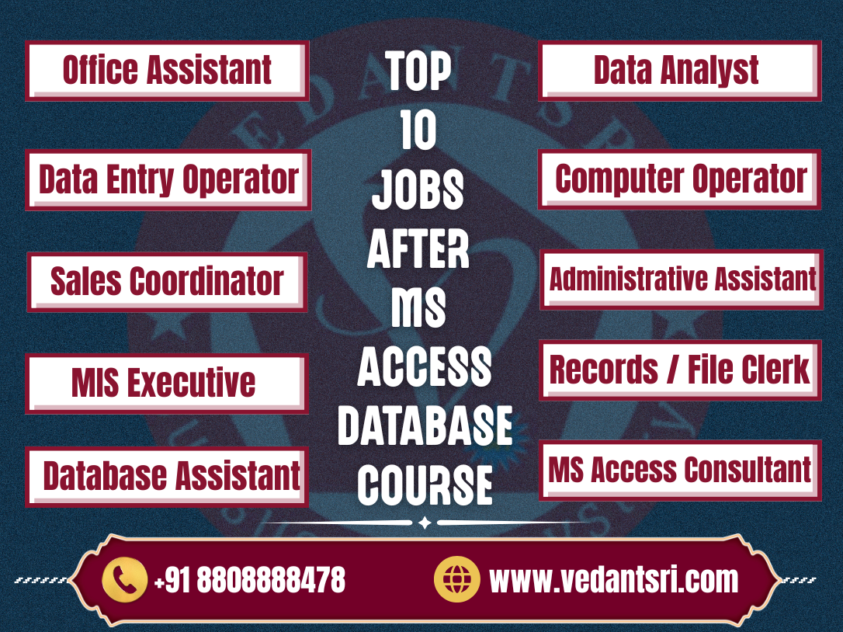
MS Access ek strong foundational skill hai jo data entry se lekar database administration tak multiple job roles me use hoti hai. Varanasi me IT aur non-IT sectors dono me MS Access ka use hota hai schools, hospitals, offices, NGOs, shops, aur small businesses me data ka organization aur reporting bahut important hota hai.
Yahan VedantSri Computer Institute ke hisaab se top 10 job roles diye gaye hain jo MS Access ke sath related hain, unke brief explanations ke saath:

1. Data Entry Operator
Ye sabse basic aur widely available job role hai.
- MS Access mein tables banane, records enter karne, update aur deletion karne ka kaam hota hai.
- Daily office data manage karna is job ka core task hota hai.

2. Office Assistant
Office ke administrative tasks handle karta hai.
- Employee details, attendance records, invoices ye sab MS Access me maintain hota hai.
- Reports and summaries banana part of the job.

3. MIS Executive (Management Information Systems)
MIS Executive ka role thoda advance hota hai.
- Data ko analyze karna
- Queries and reports banana
- Excel aur Access dono integrate karna
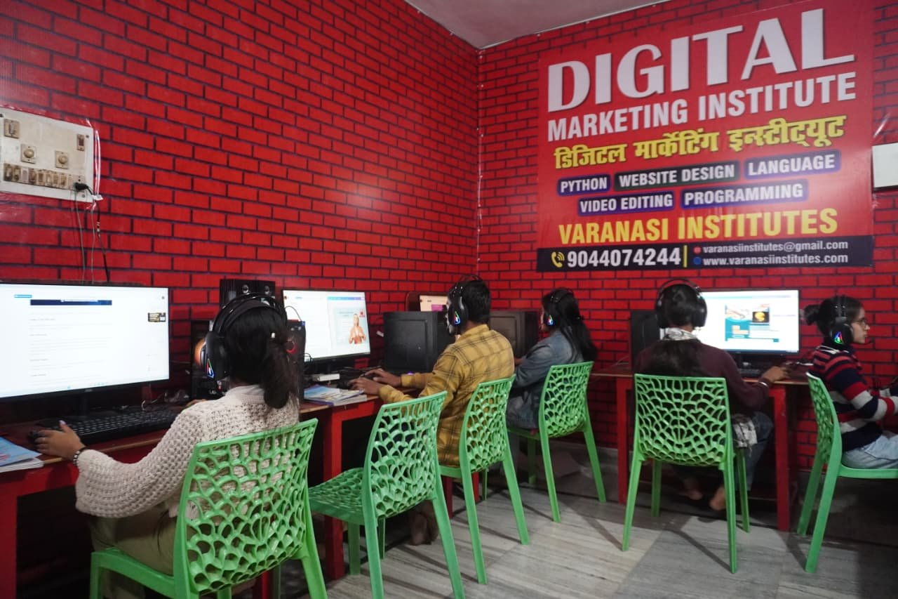
- Decision-making support provide Karna.

4. Database Assistant
Ye role organizations me database maintenance aur clean data storage handle karta hai.
- New tables and queries setup karna
- Data integrity check karna
- Backups aur updates schedule karna

5. Data Analyst (Entry Level)
Data Analyst role thoda advanced hota hai.
- Data ko presentable format me convert karna
- Reports aur dashboards banana
- SQL aur Access queries se insight nikalna

6. Computer Operator
General computing tasks handle karta hai MS Access, MS Office, and basic software use.
- Daily office tasks
- Utility programs run karna
- Print aur scanning tasks manage karna

7. Sales/Inventory Coordinator
Retail shops ya small businesses me sales aur inventory data maintain karna hota hai.
- Billing records
- Stock updates
- Customer details
- MS Access se ye kaam accurately hota hai.

8. Records / File Clerk
Institutes ya education sectors me records manage karna kaam hota hai.
- Student database
- Attendance records
- Performance reports

9. Administrative Assistant
Senior level assistant role jo Office Assistant se thoda advanced hota hai.
- MS Access + Excel + reporting
- Documentation aur scheduling
- Communication support

10. Freelancer / MS Access Consultant
Aaj freelance skill market bhi grow ho raha hai.
- Small businesses ke database design
- Custom MS Access solutions
- Project based work online

Why Choose VedantSri Computer Institute?
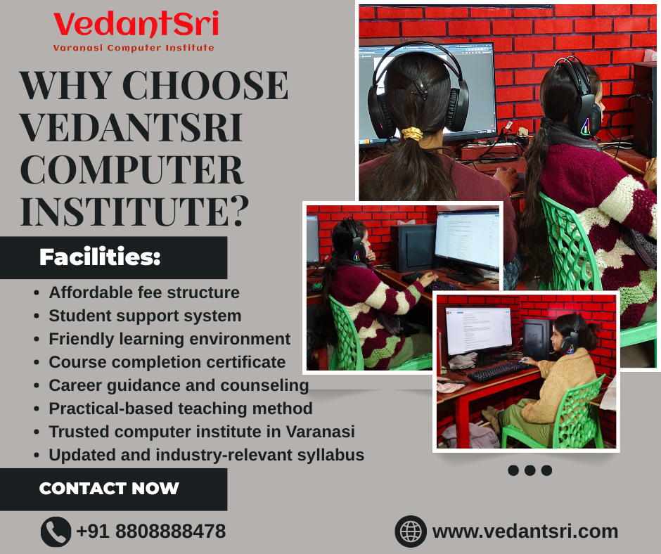
- Trusted computer institute in Varanasi
- Practical-based teaching method
- Updated and industry-relevant syllabus
- Affordable fee structure
- Student support system
- Career guidance and counseling
- Course completion certificate
- Friendly learning environment

VedantSri Institute ka mission hai:
“Students ko sirf certificate dena nahi, balki unhe real skills sikhakar career ke liye prepare karna.”

Conclusion
Agar aap short-term aur practical based course ki talash me hain, to DFA (Diploma in Financial Accounting) Computer Course ek accha choice hai. Is course me Tally, GST, Accounting, Excel aur Finance se related skills sikhayi jaati hain, jo accounting aur office jobs ke liye kaafi useful hoti hain. VedantSri Institute, Varanasi me DFA course experienced trainers ke saath affordable fees me karaya jaata hai, jisse students ko jaldi job-ready banaya ja sake.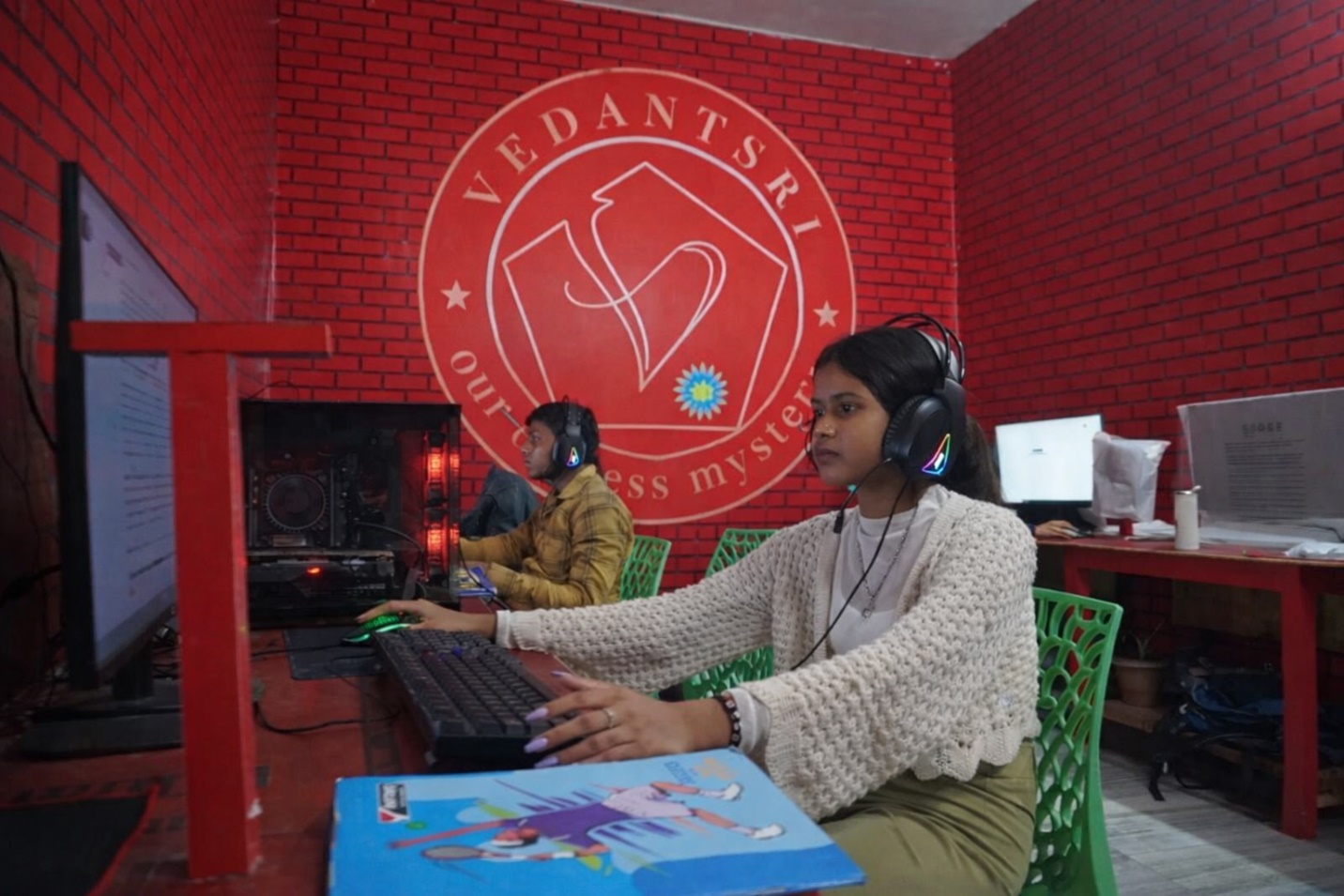
Agar aap Varanasi me rehte hain aur ek government-recognized, job-oriented aur long-term computer course karna chahte hain, to O Level Computer Course aapke liye ek behtar option ho sakta hai. Is course me aapko computer fundamentals, programming, web design, networking aur IT tools ki proper training di jaati hai, jo aage chal kar sarkari aur private dono tarah ki jobs ke liye madadgaar hoti hai. Agar aap institute ko lekar confused hain, to VedantSri Institute me aakar is course ki complete jankari le sakte hain.

Is course ke through aap:
- Database management seekh sakte hain
- Office aur administrative jobs ke liye prepare ho sakte hain
- Future IT (Information Technology) courses ke liye strong foundation bana sakte hai

CONTACT & REGISTRATION
Get Started Today! Vedant Sri Computer Education Your Gateway to a Successful.

Contact Details
• Address: Kabir Nagar, Durga Kund, Varanasi
• Phone: 8808888478 | 9415802061
• WhatsApp: 8808888478
• Email: vedantsri0@gmail.com
• Website: vedantsri.com
• Second Website: vedantsri.net

